SOFTWARE ENVIRONMENT

What is Python?
Below are some facts about Python.
- Python is currently the most widely used multi-purpose, high-level programming language.
- Python allows programming in Object-Oriented and Procedural paradigms. Python programs generally are smaller than other programming languages like Java.
- Programmers have to type relatively less and indentation requirement of the language, makes them readable all the time.
- Python language is being used by almost all tech-giant companies like – Google, Amazon, Facebook, Instagram, Dropbox, Uber… etc.
The biggest strength of Python is huge collection of standard library which can be used for the following –
  - Machine Learning
  - GUI Applications (like Kivy, Tkinter, PyQt etc. )
  - Web frameworks like Django (used by YouTube, Instagram, Dropbox)
  - Image processing (like Opencv, Pillow)
  - Web scraping (like Scrapy, BeautifulSoup, Selenium)
  - Test frameworks
  - Multimedia

Advantages of Python
Let’s see how Python dominates over other languages.
1. Extensive Libraries
Python downloads with an extensive library and it contain code for various purposes like regular expressions, documentation-generation, unit-testing, web browsers, threading, databases, CGI, email, image manipulation, and more. So, we don’t have to write the complete code for that manually.
2. Extensible
As we have seen earlier, Python can be extended to other languages. You can write some of your code in languages like C++ or C. This comes in handy, especially in projects.
3. Embeddable
Complimentary to extensibility, Python is embeddable as well. You can put your Python code in your source code of a different language, like C++. This lets us add scripting capabilities to our code in the other language.
4. Improved Productivity
The language’s simplicity and extensive libraries render programmers more productive than languages like Java and C++ do. Also, the fact that you need to write less and get more things done.
5. IOT Opportunities
Since Python forms the basis of new platforms like Raspberry Pi, it finds the future bright for the Internet Of Things. This is a way to connect the language with the real world.
6. Simple and Easy
When working with Java, you may have to create a class to print ‘Hello World’. But in Python, just a print statement will do. It is also quite easy to learn, understand, and code. This is why when people pick up Python, they have a hard time adjusting to other more verbose languages like Java.
7. Readable
Because it is not such a verbose language, reading Python is much like reading English. This is the reason why it is so easy to learn, understand, and code. It also does not need curly braces to define blocks, and indentation is mandatory. This further aids the readability of the code.
8. Object-Oriented
This language supports both the procedural and object-oriented programming paradigms. While functions help us with code reusability, classes and objects let us model the real world. A class allows the encapsulation of data and functions into one.
9. Free and Open-Source
Like we said earlier, Python is freely available. But not only can you download Python for free, but you can also download its source code, make changes to it, and even distribute it. It downloads with an extensive collection of libraries to help you with your tasks.
10. Portable
When you code your project in a language like C++, you may need to make some changes to it if you want to run it on another platform. But it isn’t the same with Python. Here, you need to code only once, and you can run it anywhere. This is called Write Once Run Anywhere (WORA). However, you need to be careful enough not to include any system-dependent features.
11. Interpreted
Lastly, we will say that it is an interpreted language. Since statements are executed one by one, debugging is easier than in compiled languages.
Any doubts till now in the advantages of Python? Mention in the comment section.
Advantages of Python Over Other Languages
1. Less Coding
Almost all of the tasks done in Python requires less coding when the same task is done in other languages. Python also has an awesome standard library support, so you don’t have to search for any third-party libraries to get your job done. This is the reason that many people suggest learning Python to beginners.
2. Affordable
Python is free therefore individuals, small companies or big organizations can leverage the free available resources to build applications. Python is popular and widely used so it gives you better community support.
The 2019 Github annual survey showed us that Python has overtaken Java in the most popular programming language category.
3. Python is for Everyone
Python code can run on any machine whether it is Linux, Mac or Windows. Programmers need to learn different languages for different jobs but with Python, you can professionally build web apps, perform data analysis and machine learning, automate things, do web scraping and also build games and powerful visualizations. It is an all-rounder programming language.
Disadvantages of Python
So far, we’ve seen why Python is a great choice for your project. But if you choose it, you should be aware of its consequences as well. Let’s now see the downsides of choosing Python over another language.
1. Speed Limitations
We have seen that Python code is executed line by line. But since Python is interpreted, it often results in slow execution. This, however, isn’t a problem unless speed is a focal point for the project. In other words, unless high speed is a requirement, the benefits offered by Python are enough to distract us from its speed limitations.
2. Weak in Mobile Computing and Browsers
While it serves as an excellent server-side language, Python is much rarely seen on the client-side. Besides that, it is rarely ever used to implement smartphone-based applications. One such application is called Carbonnelle.
The reason it is not so famous despite the existence of Brython is that it isn’t that secure.
3. Design Restrictions
As you know, Python is dynamically-typed. This means that you don’t need to declare the type of variable while writing the code. It uses duck-typing. But wait, what’s that? Well, it just means that if it looks like a duck, it must be a duck. While this is easy on the programmers during coding, it can raise run-time errors.
4. Underdeveloped Database Access Layers
Compared to more widely used technologies like JDBC (Java DataBase Connectivity) and ODBC (Open DataBase Connectivity), Python’s database access layers are a bit underdeveloped. Consequently, it is less often applied in huge enterprises.
5. Simple
No, we’re not kidding. Python’s simplicity can indeed be a problem. Take my example. I don’t do Java, I’m more of a Python person. To me, its syntax is so simple that the verbosity of Java code seems unnecessary.
This was all about the Advantages and Disadvantages of Python Programming Language.
History of Python
What do the alphabet and the programming language Python have in common? Right, both start with ABC. If we are talking about ABC in the Python context, it's clear that the programming language ABC is meant. ABC is a general-purpose programming language and programming environment, which had been developed in the Netherlands, Amsterdam, at the CWI (Centrum Wiskunde &Informatica). The greatest achievement of ABC was to influence the design of Python. Python was conceptualized in the late 1980s. Guido van Rossum worked that time in a project at the CWI, called Amoeba, a distributed operating system. In an interview with Bill Venners¹, Guido van Rossum said: "In the early 1980s, I worked as an implementer on a team building a language called ABC at Centrum voor Wiskunde en Informatica (CWI). I don't know how well people know ABC's influence on Python. I try to mention ABC's influence because I'm indebted to everything I learned during that project and to the people who worked on it. "Later on in the same Interview, Guido van Rossum continued: "I remembered all my experience and some of my frustration with ABC. I decided to try to design a simple scripting language that possessed some of ABC's better properties, but without its problems. So I started typing. I created a simple virtual machine, a simple parser, and a simple runtime. I made my own version of the various ABC parts that I liked. I created a basic syntax, used indentation for statement grouping instead of curly braces or begin-end blocks, and developed a small number of powerful data types: a hash table (or dictionary, as we call it), a list, strings, and numbers."

Python Development Steps
Guido Van Rossum published the first version of Python code (version 0.9.0) at alt.sources in February 1991. This release included already exception handling, functions, and the core data types of list, dict, str and others. It was also object oriented and had a module system.
Python version 1.0 was released in January 1994. The major new features included in this release were the functional programming tools lambda, map, filter and reduce, which Guido Van Rossum never liked. Six and a half years later in October 2000, Python 2.0 was introduced. This release included list comprehensions, a full garbage collector and it was supporting unicode. Python flourished for another 8 years in the versions 2.x before the next major release as Python 3.0 (also known as "Python 3000" and "Py3K") was released. Python 3 is not backwards compatible with Python 2.x. The emphasis in Python 3 had been on the removal of duplicate programming constructs and modules, thus fulfilling or coming close to fulfilling the 13th law of the Zen of Python: "There should be one -- and preferably only one -- obvious way to do it."Some changes in Python 7.3:
- Print is now a function.
- Views and iterators instead of lists
- The rules for ordering comparisons have been simplified. E.g., a heterogeneous list cannot be sorted, because all the elements of a list must be comparable to each other.
- There is only one integer type left, i.e., int. long is int as well.
- The division of two integers returns a float instead of an integer. "//" can be used to have the "old" behaviour.
- Text Vs. Data Instead of Unicode Vs. 8-bit
Purpose
We demonstrated that our approach enables successful segmentation of intra-retinal layers—even with low-quality images containing speckle noise, low contrast, and different intensity ranges throughout—with the assistance of the ANIS feature.
Python
Python is an interpreted high-level programming language for general-purpose programming. Created by Guido van Rossum and first released in 1991, Python has a design philosophy that emphasizes code readability, notably using significant whitespace.
Python features a dynamic type system and automatic memory management. It supports multiple programming paradigms, including object-oriented, imperative, functional and procedural, and has a large and comprehensive standard library.
- Python is Interpreted − Python is processed at runtime by the interpreter. You do not need to compile your program before executing it. This is similar to PERL and PHP.
- Python is Interactive − you can actually sit at a Python prompt and interact with the interpreter directly to write your programs.
Python also acknowledges that speed of development is important. Readable and terse code is part of this, and so is access to powerful constructs that avoid tedious repetition of code. Maintainability also ties into this may be an all but useless metric, but it does say something about how much code you have to scan, read and/or understand to troubleshoot problems or tweak behaviors. This speed of development, the ease with which a programmer of other languages can pick up basic Python skills and the huge standard library is key to another area where Python excels. All its tools have been quick to implement, saved a lot of time, and several of them have later been patched and updated by people with no Python background - without breaking.
Modules Used in Project
TensorFlow
TensorFlow is a free and open-source software library for dataflow and differentiable programming across a range of tasks. It is a symbolic math library and is also used for machine learning applications such as neural networks. It is used for both research and production at Google.‍
TensorFlow was developed by the Google Brain team for internal Google use. It was released under the Apache 2.0 open-source license on November 9, 2015.
NumPy
NumPy is a general-purpose array-processing package. It provides a high-performance multidimensional array object, and tools for working with these arrays.
It is the fundamental package for scientific computing with Python. It contains various features including these important ones:
- A powerful N-dimensional array object
- Sophisticated (broadcasting) functions
- Tools for integrating C/C++ and Fortran code
- Useful linear algebra, Fourier transform, and random number capabilities
Besides its obvious scientific uses, NumPy can also be used as an efficient multi-dimensional container of generic data. Arbitrary datatypes can be defined using NumPy which allows NumPy to seamlessly and speedily integrate with a wide variety of databases.
Pandas
Pandas is an open-source Python Library providing high-performance data manipulation and analysis tool using its powerful data structures. Python was majorly used for data munging and preparation. It had very little contribution towards data analysis. Pandas solved this problem. Using Pandas, we can accomplish five typical steps in the processing and analysis of data, regardless of the origin of data load, prepare, manipulate, model, and analyze. Python with Pandas is used in a wide range of fields including academic and commercial domains including finance, economics, Statistics, analytics, etc.
Matplotlib
Matplotlib is a Python 2D plotting library which produces publication quality figures in a variety of hardcopy formats and interactive environments across platforms. Matplotlib can be used in Python scripts, the Python and IPython shells, the Jupyter Notebook, web application servers, and four graphical user interface toolkits. Matplotlib tries to make easy things easy and hard things possible. You can generate plots, histograms, power spectra, bar charts, error charts, scatter plots, etc., with just a few lines of code. For examples, see the sample plots and thumbnail gallery.
For simple plotting the pyplot module provides a MATLAB-like interface, particularly when combined with IPython. For the power user, you have full control of line styles, font properties, axes properties, etc, via an object oriented interface or via a set of functions familiar to MATLAB users.
Scikit – learn
Scikit-learn provides a range of supervised and unsupervised learning algorithms via a consistent interface in Python. It is licensed under a permissive simplified BSD license and is distributed under many Linux distributions, encouraging academic and commercial use. Python
Python is an interpreted high-level programming language for general-purpose programming. Created by Guido van Rossum and first released in 1991, Python has a design philosophy that emphasizes code readability, notably using significant whitespace.
Python features a dynamic type system and automatic memory management. It supports multiple programming paradigms, including object-oriented, imperative, functional and procedural, and has a large and comprehensive standard library.
- Python is Interpreted − Python is processed at runtime by the interpreter. You do not need to compile your program before executing it. This is similar to PERL and PHP.
- Python is Interactive − you can actually sit at a Python prompt and interact with the interpreter directly to write your programs.
Python also acknowledges that speed of development is important. Readable and terse code is part of this, and so is access to powerful constructs that avoid tedious repetition of code. Maintainability also ties into this may be an all but useless metric, but it does say something about how much code you have to scan, read and/or understand to troubleshoot problems or tweak behaviors. This speed of development, the ease with which a programmer of other languages can pick up basic Python skills and the huge standard library is key to another area where Python excels. All its tools have been quick to implement, saved a lot of time, and several of them have later been patched and updated by people with no Python background - without breaking.
Install Python Step-by-Step in Windows and Mac
Python a versatile programming language doesn’t come pre-installed on your computer devices. Python was first released in the year 1991 and until today it is a very popular high-level programming language. Its style philosophy emphasizes code readability with its notable use of great whitespace.
The object-oriented approach and language construct provided by Python enables programmers to write both clear and logical code for projects. This software does not come pre-packaged with Windows.
How to Install Python on Windows and Mac
There have been several updates in the Python version over the years. The question is how to install Python? It might be confusing for the beginner who is willing to start learning Python but this tutorial will solve your query. The latest or the newest version of Python is version 3.7.4 or in other words, it is Python 3.
Note: The python version 3.7.4 cannot be used on Windows XP or earlier devices.
Before you start with the installation process of Python. First, you need to know about your System Requirements. Based on your system type i.e. operating system and based processor, you must download the python version. My system type is a Windows 64-bit operating system. So the steps below are to install python version 3.7.4 on Windows 7 device or to install Python 3. Download the Python Cheatsheet here.The steps on how to install Python on Windows 10, 8 and 7 are divided into 4 parts to help understand better.
Download the Correct version into the system
Step 1: Go to the official site to download and install python using Google Chrome or any other web browser. OR Click on the following link: https://www.python.org
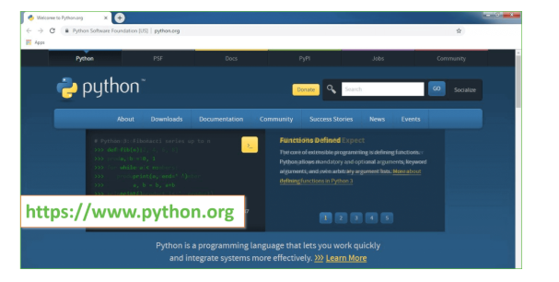
Now, check for the latest and the correct version for your operating system.
Step 2: Click on the Download Tab.
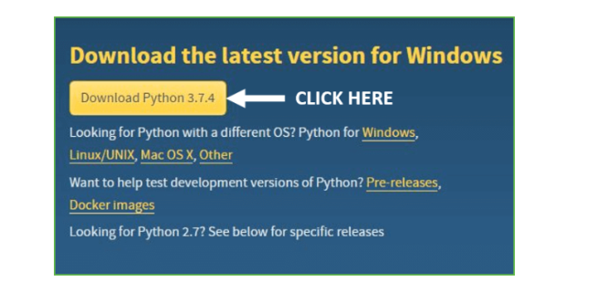
Step 3: You can either select the Download Python for windows 3.7.4 button in Yellow Color or you can scroll further down and click on download with respective to their version. Here, we are downloading the most recent python version for windows 3.7.4
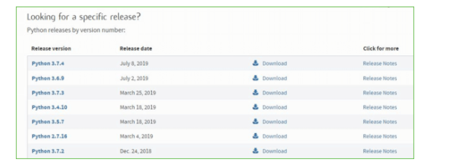
Step 4: Scroll down the page until you find the Files option.
Step 5: Here you see a different version of python along with the operating system.
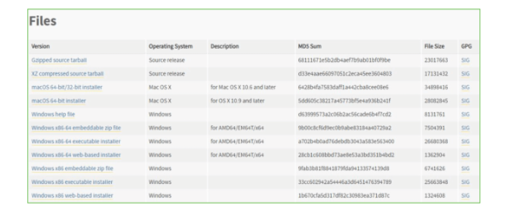
- To download Windows 32-bit python, you can select any one from the three options: Windows x86 embeddable zip file, Windows x86 executable installer or Windows x86 web-based installer.
- To download Windows 64-bit python, you can select any one from the three options: Windows x86-64 embeddable zip file, Windows x86-64 executable installer or Windows x86-64 web-based installer.
Here we will install Windows x86-64 web-based installer. Here your first part regarding which version of python is to be downloaded is completed. Now we move ahead with the second part in installing python i.e. Installation
Note: To know the changes or updates that are made in the version you can click on the Release Note Option.
Installation of Python
Step 1: Go to Download and Open the downloaded python version to carry out the installation process.
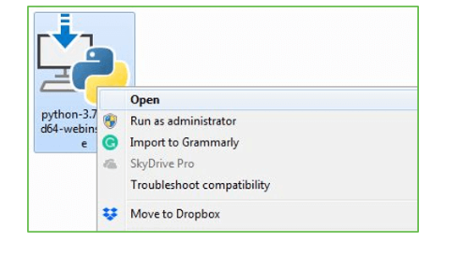
Step 2: Before you click on Install Now, Make sure to put a tick on Add Python 3.7 to PATH.
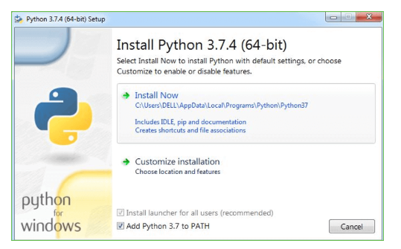
Step 3: Click on Install NOW After the installation is successful. Click on Close.
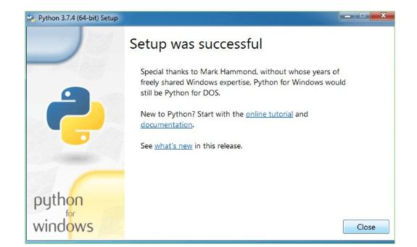
With these above three steps on python installation, you have successfully and correctly installed Python. Now is the time to verify the installation.
Note: The installation process might take a couple of minutes.
Verify the Python Installation
Step 1: Click on Start
Step 2: In the Windows Run Command, type “cmd”.

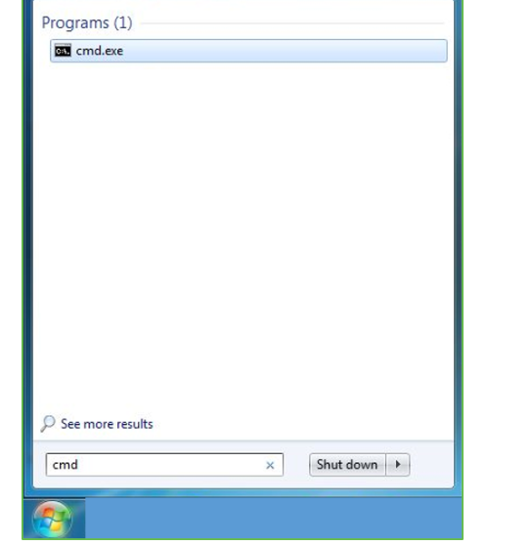
Step 3: Open the Command prompt option.
Step 4: Let us test whether the python is correctly installed. Type python –V and press Enter.
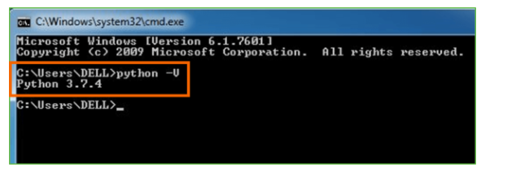
Step 5: You will get the answer as 3.7.4
Note: If you have any of the earlier versions of Python already installed. You must first uninstall the earlier version and then install the new one.
Check how the Python IDLE works
Step 1: Click on Start
Step 2: In the Windows Run command, type “python idle”.
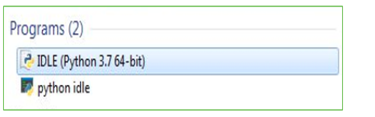
Step 3: Click on IDLE (Python 3.7 64-bit) and launch the program
Step 4: To go ahead with working in IDLE you must first save the file. Click on File > Click on Save
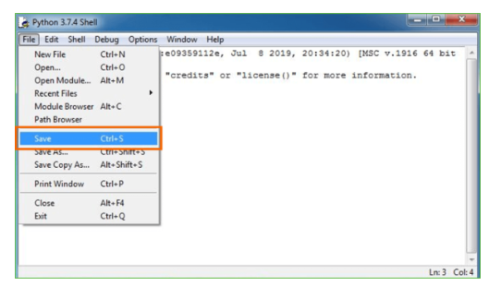
Step 5: Name the file and save as type should be Python files. Click on SAVE. Here I have named the files as Hey World.
Step 6: Now for e.g. enter print (“Hey World”) and Press Enter.
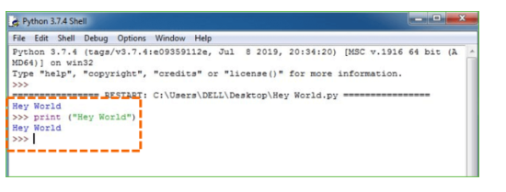
You will see that the command given is launched. With this, we end our tutorial on how to install Python. You have learned how to download python for windows into your respective operating system.
Note: Unlike Java, Python does not need semicolons at the end of the statements otherwise it won’t work.

